Name Date
End of Unit 2 test
Vocabulary 1
Match each mathematical word with the correct shape.

 | Mathematical word | Answer |  |  | Shape
0 | cube | A |  | A | 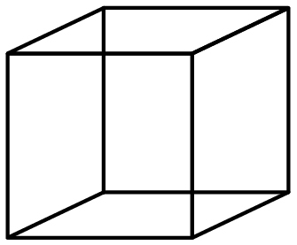
1 | hexagonal prism |  |  | B | 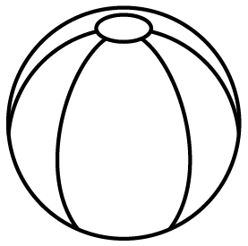
2 | hemisphere |  |  | C | 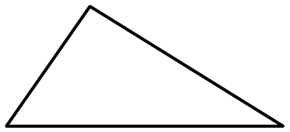
3 | cone |  |  | D | 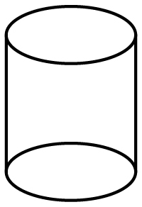
4 | triangular pyramid |  |  | E | 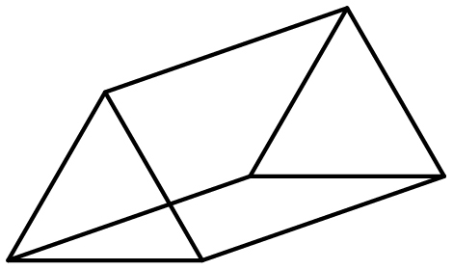
5 | cylinder |  |  | F | 

 | Mathematical word | Answer |  |  | Shape
6 | sphere |  |  | G | 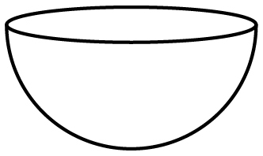
7 | rectangle |  |  | H | 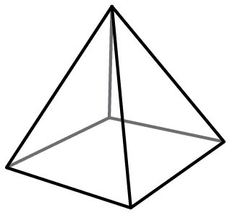
8 | square-based pyramid |  |  | I | 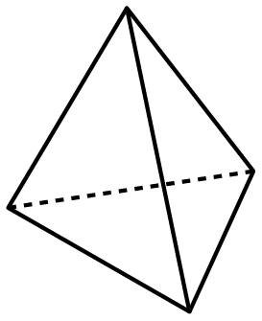
9 | triangle |  |  | J | 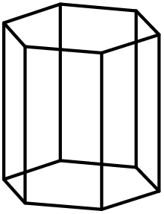
10 | triangular prism |  |  | K | 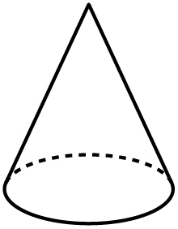

[Total: 10 marks]
Grammar 1 and 2
Use the words in brackets to write each sentence out correctly using the second conditional.
Example:
- If footballs (are) square, football (be) a very difficult game to play.
…………………………………………………………………………………
If footballs were square, football would be a very difficult game to play.

- I (walk) to school if it (not be) such a long way.
………………………………………………………………………………..………………………..

- If we (live) in a big city, we (have) lots of things to do.
………………………………………………………………………………..………………………..

- Where you (go) if you (can) visit any city in the world?
………………………………………………………………………………..………………………..

- If Rosie’s parents (buy) a farm, she (be) very happy.
………………………………………………………………………………..………………………..

- What kind of house you (buy) if you (have) enough money?
………………………………………………………………………………..………………………..

- If I (can) choose to do any job in the world, I (become) a scientist.
………………………………………………………………………………..………………………..

- If buildings in cities all (have) the same design, everywhere (look) the same.
………………………………………………………………………………..………………………..

- If you (be able to) design your own school, what kind of building (choose)?
………………………………………………………………………………..………………………..

- If Danny (pass) his driving test, he (get) a car.
………………………………………………………………………………..………………………..

- What you (make) if someone really famous (come) to your house for dinner?
………………………………………………………………………………..………………………..

[Total: 10 marks]

Vocabulary 2
Use a word from the box to complete the partitives.
can | tin | slice | bunch | bar | jar
bottle | box | loaf | carton | bag

Example:
……………..
- a can of cola

- a …………… of water

- a …………… of jam

- a …………… of yoghurt

- a …………… of tomatoes

- a …………… of bread

- a …………… of flowers

- a …………… of potatoes

- a …………… of chocolate

- a …………… of cake

- a …………… of matches

[Total: 10 marks]

Grammar 3
For each question, use a preposition from the box to complete the relative clause.
at | of | to | for | in | through

Example:
………….
- We went to the beach at which the children prefer to swim.

- The forest …………. which the village was found was the biggest in the country.

- Our hotel room had a huge window, …………. which you could see the sea.

- It’s a club …………. which many of the world’s most famous players belong.

- He’s the manager ………….. whom my mum worked for more than ten years.

- He’s directed many films, …………. which The Race is probably the most famous.

[Total: 5 marks]

Grammar 4
Add the correct prepositions to complete the questions.
Example:
…………….
- From which building can you see the River Seine?

- …………… which island can you find the ancient site of Knossos?

- …………… what time does the sun set today?

- …………… which country is the ancient city of Angkor?

- …………… which country did Captain Cook leave to travel to Australia?

- …………… whom did the ancient king Nebuchadnezzar II give the Hanging Gardens of Babylon?

[Total: 5 marks]

